

**F897698**

**QA review for emails without reply**

< Version 1.0 >

Feb,14 2023

**Document Revision History**

|  |  |  |  |
| --- | --- | --- | --- |
| **Version** | **Date** | **Description** | **Contributors** |
| 0.1 | 11/3/2022 | Document initial development | Roman Vatrasevych |
| 0.2 | 11/10/2022 | Document updated after review | Roman Vatrasevych |
| 0.3 | 11/14/2022 | Minor changes | Ali Mohamad |
| 0.4 | 11/15/2022 | Improved flow diagram | Roman Vatrasevych |
| 1.0 | 2/14/2023 | Final version | Roman Vatrasevych |

Contents

1. Requirements 4

2. Service description 4

3. Email flow 5

4. Service development 7

4.1 Rule Engine 7

4.2 Interaction queue 7

4.3 SCXML application 8

4.4 Business attribute for QA Disposition code 9

4.5 Case data 10

5. Service configuration 11

6. Tests 14

# Requirements

OptumRX needs a QA/Audit functionality to view items that were marked as "done" without ever sending a response to the customer.

Requirements:

1. The system provides a method of sorting all emails to isolate the ones marked as “done” without customers receiving a response.
2. The system provides a method changing a message status that was previously set to “done”
3. The system allows emails that were previously “done” to be assigned to an agent.

# Service description

After email interaction been processed by an agent, the workflow will check if a Feature “2. Feature Activation –QA for emails without reply” was configured to activate QA validation process.

If QA validation process was enabled and email processing was completed without a reply, interaction will be distributed to a supervisor.

To provide better information to Supervisor WWE Case Data of a reviewing email has extended format with presentation of information:

* Reason for QA “The email closed without a reply”
* Agent’s name who processed interaction
* Applied Disposition code

To complete QA processing and apply QA result Supervisor should select a Disposition code from an available list:

* Confirmed to close
* Return to an agent

This will be a new Business attribute to create.

Based on the selected Disposition code email interaction will be closed or returned to an agent for processing with displaying a reason of a QA review to an agent. If the email interaction is sent back to an agent, the original Disposition code list should be viewed.

During a QA processing Supervisor can use WWE existing functionality to transfer email to another agent

# Email flow



# Service development

## Rule Engine

Action is required in Rule engine for service activation:

Name: “2. Feature Activation – QA for emails without reply”

KVP: QAEmailNotReplied

Type: Boolean

## Interaction queue

Email processing has already an Interaction queue for handling of processed email interactions

Interaction Queue name: Enterprise_Digital.Chat.ProcessTranscript

Attached SCXML workflow: MngTranscriptFlow

## SCXML application

Existing SCXML flow should be changed to add email QA processing:

SCXML flow name: MngTranscriptFlow

Processing logic:



## Business attribute for QA Disposition code

Supervisor should have a QA list for disposition code.

Required list is applied before distributing an interaction to a QA Supervisor

KVP: DIG_QADispositionCD

Values: Return to Agent

Confirmed to close

## Case data

Case data requires parameters to be displayed for reviewed email for Supervisor and for an agent in case of a returned or transferred email.

Case data for Supervisor

|  |  |  |  |
| --- | --- | --- | --- |
| Displayed name | KVP | Value | Description |
| QA reason | DIG_QA | Depends on QA reason | Notify a Supervisor about reason for QA |
| Agent | IW_LastCalledAgent_EmployeeID | Agent’s Employee ID | Inform Supervisor about an agent who processed the interaction |
| Disposition code | ENT_DispositionCD | Applied Disposition code | Inform Supervisor about a selected disposition code |
| QA Disposition code | DIG_QADispositionCD | true/false | Validate interaction to be closed |

Case data for Agent

|  |  |  |  |
| --- | --- | --- | --- |
| Displayed name | KVP | Value | Description |
| QA Result | DIG_QAResult | Depends on QA reason | Notify an agent about QA result |

# Service configuration

To configure service 3 actions should be done:

1. Create LOB QA Case data.

Example:

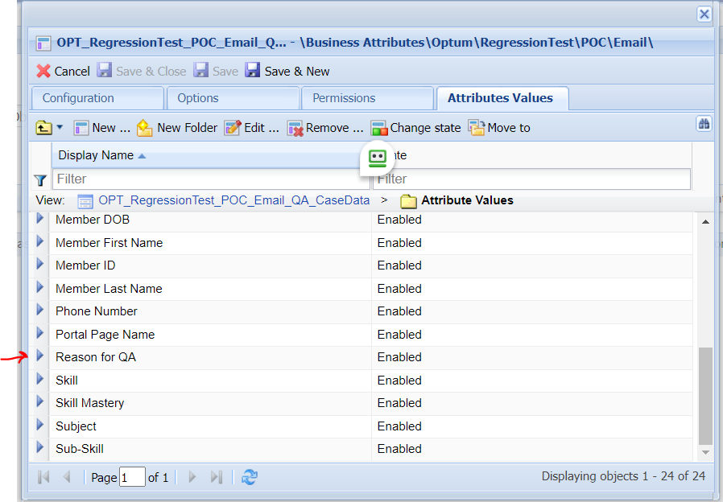

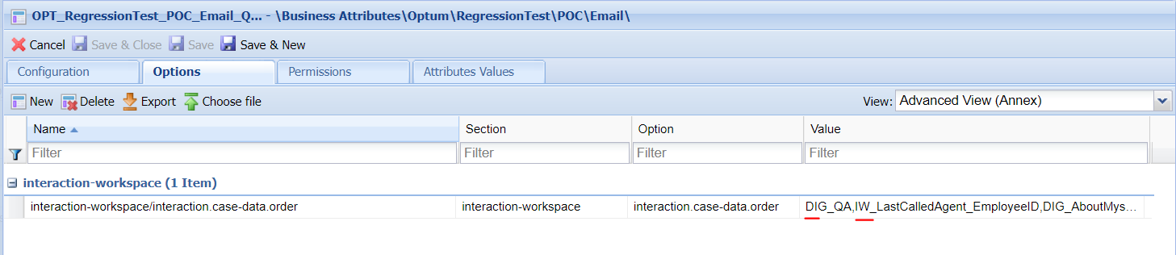

1. Add QA value to LOB case data.

Example:

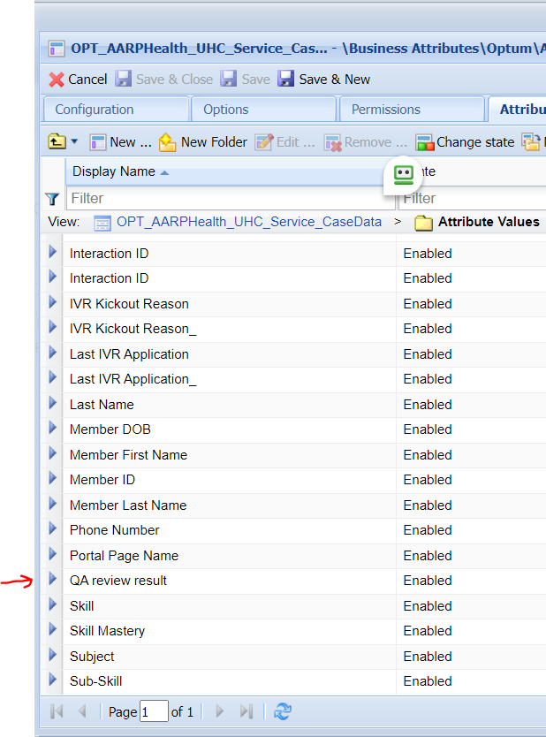

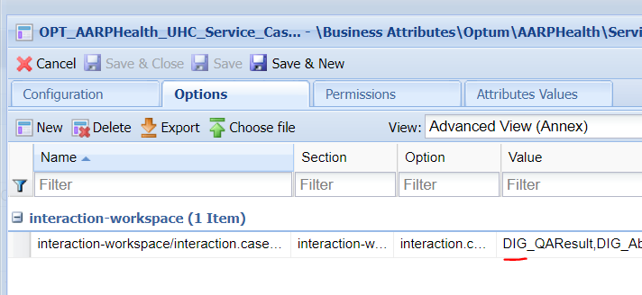

1. Create LOB QA transaction list to overwrite WWE options for Case data and Disposition codes.

Example:

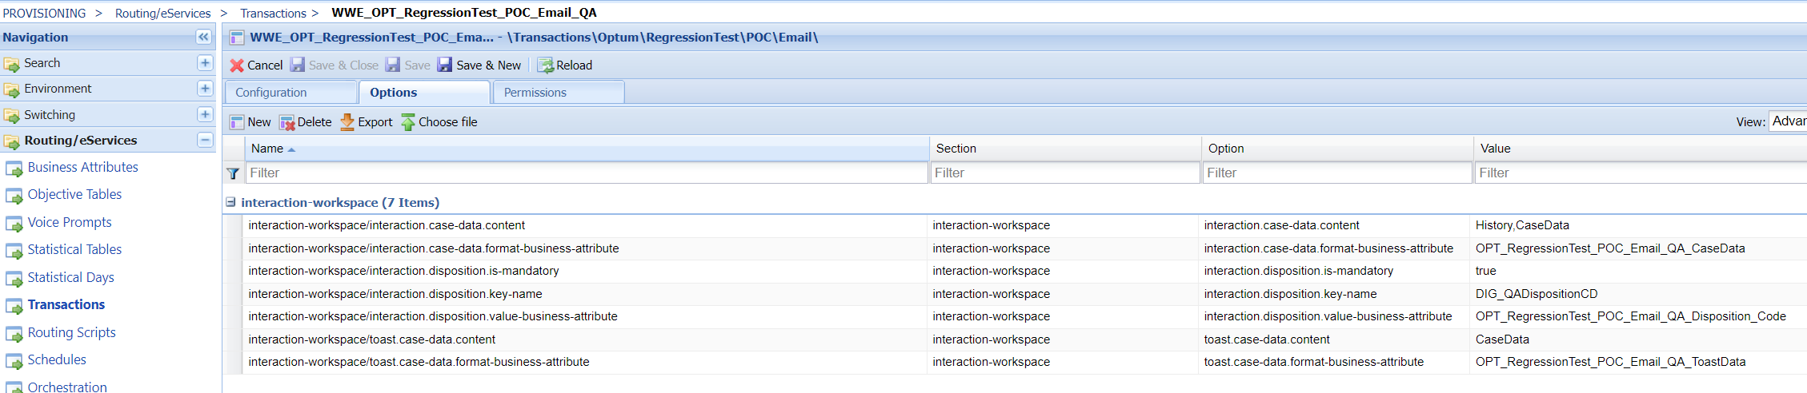

1. Configure transaction list name in routing LOB JSON option “iw_override_key_qa”

Example:

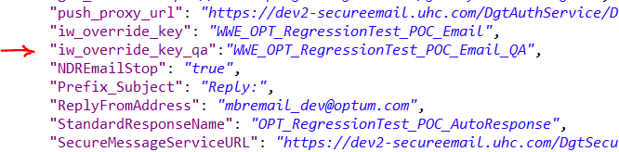

1. Configure target for QA Supervisors.

Example:

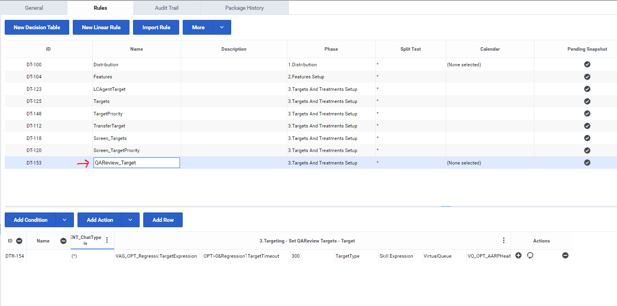

1. Activate service Feature in Rules for LOB:

“2. Feature Activation – QA for not replied emails enabled” = true

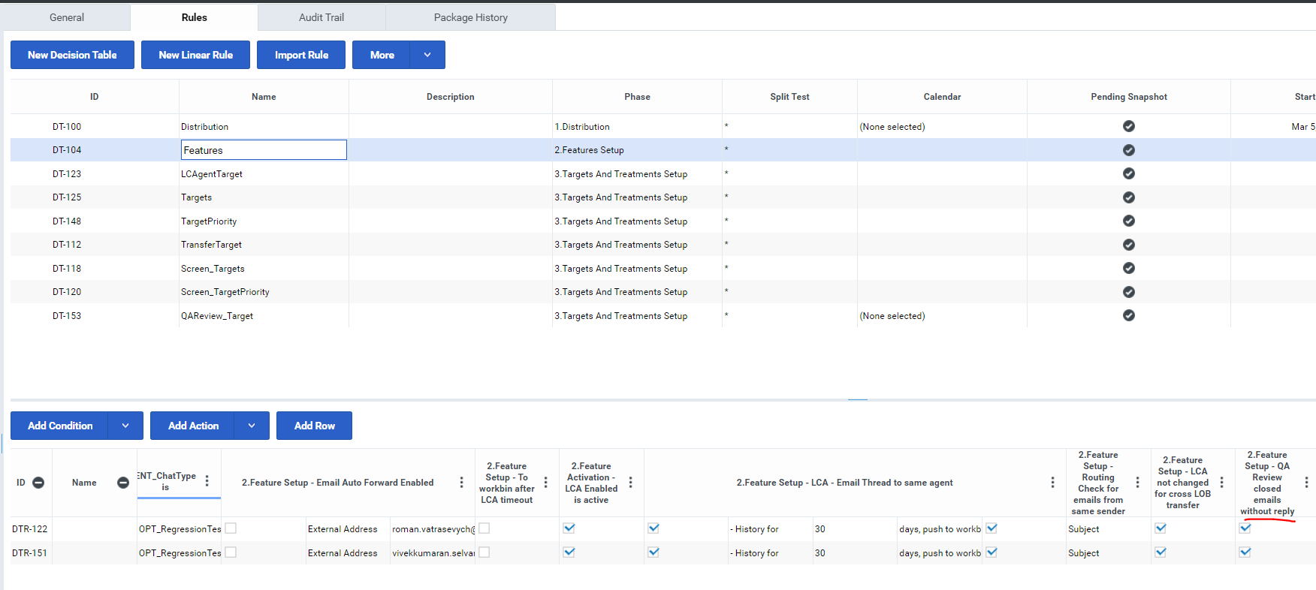

# Tests

To test service required:

* Test Agent 1
* Test Agent 2
* Supervisor

Test steps:

1. An agent 1 login to WWE
2. An agent 2 login to WWE
3. An agent processes 6 emails 4 emails of them are without a reply.

Subjects are:

* “QA Test validate”
* “QA Test returned”
* “QA Test distribute”
* “QA Test postpone”

1. Supervisor login to WWE in 5 minutes
2. Supervisor validates that email with provided above subjects are routed to him. For every QA email Case data should have a QA reason and Disposition codes have 2 items only for QA process.

Email should be processed:

* Email with subject “QA Test validate”: selected “Confirmed to close” disposition code and pressed “Mark Done”
* Email with subject “QA Test returned”: selected “Return to agent” disposition code and pressed “Mark Done”
* Email with subject “QA Test distribute”: transfered email to an agent 2
* Email with subject “QA Test postpone”: clicked on “move interaction back to workbin” button

Test results:

|  |  |  |  |
| --- | --- | --- | --- |
| Email subject | QA Disposition code | Action | Result |
| QA Test validate | Confirmed to close | Mark done | Interaction closed |
| QA Test returned | Return to agent | Mark done | Interaction returned to an agent with a result of QA review in case data |
| QA Test distribute | N/A | Transfer to Agent 2 | Interaction distributed to an agent 2 |
| QA Test postpone | N/A | Push back to workbin | Interaction is in the Emails workbin |